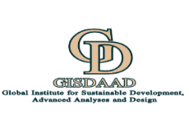



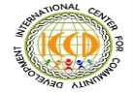

2026 ISEG-GGSD MEGA-SYMPOSIUM
BULLETIN 3.9: CALL FOR ABSTRACTS AND SPONSORS
14th International Symposium on Environmental Geotechnology and Global Sustainable Development
in conjunction with
2026 Global Geo-Ecosystems and Sustainable Development Symposium
University of Nairobi, Nairobi, Kenya, Sunday, August 9, 2026 to Saturday August 15, 2026.
  Nairobi, Kenya | 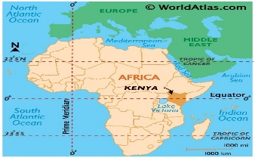  Map of Africa showing Kenya |   Nairobi, Kenya
organized
by
Global Institute of Sustainable Development, Advanced Analysis and Design (GISDAAD), Concord, NC, USA (Global headquarters) and Abuja, Nigeria.
in collaboration with
- The International Society of Environmental Geotechnology (ISEG), Nanjing, China. | - International Center for Community Development (ICCD), Concord, NC, USA.
- The African Academy of Sciences (AAS), Nairobi, Kenya.
- Future Earth, South Africa. | - Future Africa Institute, University of Pretoria, Pretoria, South Africa.

OBJECTIVES AND FOCUS OF THE TWO-PART MEGA SYMPOSIUM
This expanded two-part ISEG/GGSD-2026 Mega-Symposium is an outgrowth of 13 regular ISEG conferences/symposia which started in 1993, and many other forums with the continuing objective of applying technical and social science knowledge from a diversity of disciplines to address critical issues in sustainable development as follows:

- ISEG/GGSD-2026 Mega-Symposium Part A:  14th International Symposium on Environmental Geotechnology and Global Sustainable Development  Part A will focus on fundamental aspects of Environmental Geotechnology to be treated by experts from various parts of world, such as researchers, practicing analysts, educators and engineers to present research papers and exhibitions that will cover theoretical modeling, innovative experimentation techniques, new equipment designs, field studies and demonstration projects. Among the major issues and sub-disciplines that will be treated in several sessions are: | - ISEG/GGSD-2026 Mega-Symposium Part B:  2026 Global Geo-Ecosystems and Sustainable Development Symposium  Part B is the most recent compliment of the traditional ISEG conferences that have been held since 1993. The continuing objective of Part B of this Mega-Symposium is application of technical and social science knowledge from a diversity of disciplines to address critical issues in sustainable development. This will cover cross-disciplinary analyses of geoenvironmental issues across many socioeconomic sectors such as:
• Constitutive and numerical modeling of geomaterials  • Failure models of geomaterials (cracking and other forms of deformation), and mechanical excavation of geomaterials  • Mechanics of geohazards and ground subsidence  • Thermal, radiation and chemical processes in geomaterials  • Geoslope analyses, geofabrics and other stabilization methods • Rock mechanics, mining and geomaterials processing  • Geothermal systems for energy production; gas transport in the sub-surface; and carbon capture and disposal in geomedia  • Characterization and laboratory methods in geomaterials  • AI and robotics applications in environmental geotechnology • Innovative geomonitoring and field mapping techniques  • Geoenvironmental aspects of climate change  • Geohydrology of water and contaminant transport  • Irrigation of geomedia and conservation agriculture  • Erosion/flow of granular materials and dust control systems  • Waste disposal and containment systems in geomedia  • Design, construction, maintenance and rehabilitation of geostructures and systems  • Contaminated site remediation and waste containment techniques  • Soil stabilization with innovative materials (e.g. plastics, polymers and fibers)  • Biogeotechnology and related analytical support systems.  • Post-war landmine detection techniques  • Geochronology, including isotopes dating of geomaterials  • Marine geotechnics and mineral explorations  • Lunar and Marsian Excavation geotechnics  • Geo-medical, geo-magnetic and geo-electrical materials, and their application | • Elements of sustainable development and green economy  • Environmental laws and global treaties  • Environmental policy and regulatory frameworks  • Ecological/forestry systems and blue economy  • Climate change impacts mitigation and adaptation  • Contaminant exposure and occupational health  • Energy systems and environmental sustainability  • Agriculture and environmental systems  • Monitoring and visualization systems for risk assessment and decision support  • Contaminated sediments in rivers and lakes  • Waste recycling and wastewater management;  • Contaminant exposure pathways and noise pollution  • Natural disasters disaster/emergency response systems  • Groundwater, surface water and air pollution  • Waste disposal and containment systems  • Soil erosion and stabilization management  • Land/environmental conflict resolution techniques  • Mine site rehabilitation and tailings management systems  • Environmental impact assessments and auditing techniques  • Oil spills assessments and insurance systems  • Environmental education and indigenous knowledge systems in environmental management and environmental justice  • Environmental data archiving  • Science diplomacy for environmental conflict resolution health  • Environmental law, standards and enforcement  • Environmental Folklore and Poetry  • Environmental biotechnology and restoration  Pg. 1  • Natural resources and wildlife management
Part A will also cover ISEG Council meetings, paper award ceremonies and closing dinner for participants of Part A. ISEG will solicit for new members from various global regions to sustain its heritage of outreach to experts, including analysts, researchers and policymakers. The best papers on the thematic issues will be selected for reviews and publication in special editions of reputable peer-viewed international journals such as Environmental Geotechnology (a journal of the Institute of Civil Engineers of the UK).
Part B will also involve keynote lectures, regular 30-minute presentations of papers, panel discussions, debates, presentation of award to the best papers, exhibitions and special revival/launching of the Global Alliance for Disaster Reduction (GADR) by the Symposium host organization - Global Institute of Sustainable Development, Advanced Analysis and Design (GISDAAD). The Symposium will end with a dinner and cultural event. The website to register for the Mega-Symposium is https://iseg.gisdaad.org/.
INSTRUCTIONS FOR ABSTRACT SUBMISSION
Abstracts for Symposium Part A
- Submit 4-page abstracts with your name, institution/organization, email address and contact telephone number by April 30, 2026.
- Please prepare your abstract as a four-page, single spaced, 12-points font size (including diagrams within the 4-page limit).
- Use A4 size paper with 2.5 cm margins top and bottom and 2.0 cm margins on the sides.
- Submit your abstract online at https://iseg.gisdaad.org/.
Abstracts for Symposium Part B
- Submit 4-page abstracts with your name, institution/organization, email address and contact telephone number by April 30, 2026.
- Please prepare your abstract as a four-page, single spaced, 12-points font size (including diagrams within the 4-page limit).
- Use A4 size paper with 2.5 cm margins top and bottom and 2.0 cm margins on the sides.
- Submit your abstract online at https://iseg.gisdaad.org/.

MEGA SYMPOSIUM PLANNING CALENDAR
DATE | PLANNING ACTIVITY
August 30, 2025 | - Release of Internal Bulletin 2
October 10, 2025 | - Release of Bulletin 3: Call for Abstracts, Sponsored-Session Proposals and Exhibitions.
April 30, 2026 | - Deadline for Online Submission of 4-Page Abstracts using Specified Format.
April 30, 2026 | - Deadline for Submission of Sponsored-Session Proposals.
April 30, 2026 | - Deadline for Submission of Exhibition Plans and Registration.
June 15, 2026 | - Production of Mega Symposium Program and Call for Registration – Bulletin 4
June 30, 2026 | - Deadline for Regular Registration  - Deadline for Registration for Shortcourses. (https://iseg.gisdaad.org/)
August 9, 2026 | - Beginning of the Mega-Symposium
August 14, 2026 | - Closing Ceremony of the Mega Symposium
August 15, 2026 | - Mega-Symposium Shortcourses.
Pg. 2
SPECIAL OFFER TO PARTICIPANTS
The Symposium will also cover the following features for enjoyment by participants and their families in Kenya, a country that is noted for tourism. Details of the following offers are provided on the website: https://iseg.gisdaad.org/.
- Several presentation sessions, discussion panels and exhibitions focused on policy, management methods and technologies on cross-cutting issues about environmental sustainability across several socioeconomic sectors.
- A set of training workshops including those on research performance methods, research management methods, climate change impacts assessment and management, natural disaster/hazard management, environmental/health risk exposure assessment, all to be held on Saturday, August 15, 2026.
- A Youth Environmental and Climate Change Forum (YECCF) that would bring bright teenagers from around the world to engage in discussions about this critical issues.
- A full-fledged, full day Safari Tour of the two most important animal parks and one of the largest zoos in Africa (to be held on Wednesday, August 12, 2026) that will separate the two parts of the Mega Symposium.
- A cultural night on Friday, August 14, 2026 that will feature cultural dances, poetry renditions and music.
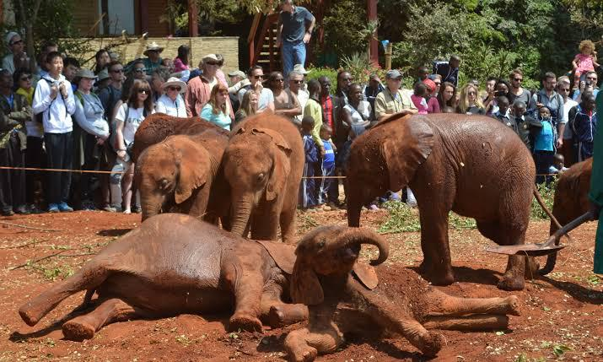
Tourists at the Nairobi National Park
MEGA SYMPOSIUM STRUCTURE AND SCHEDULE
PART A
Day 1, Sunday,  August 9, 2026 | - Arrival of participants
Day 2, Monday,  August 10, 2026 | - On-Site Registration for Part A  - Opening Ceremony for Part A  - Keynote Presentations  - Parallel Session Presentations  - ISEG Council Meeting (evening)  - ISEG Elections (evening)
Day 3, Tuesday,  August 11, 2026 | - Paper Presentations In Parallel Sessions  - Poster Papers  - ISEG Awards And Prizes  - Part A Closing Dinner
Day 4, Wed.,  August 12, 2026 | - Safari Tour of the Nairobi National Park (6 Am - 12 Noon)  - Organized lunch in Nairobi (12 noon)  - Tour of Nairobi National Museum (3-5pm)
PART B
Day 5,Thursday,  August 13, 2026 | - On-site Registration for Part B  - Opening Ceremony for Part B  - Relaunching of the Global Alliance for Disaster Reduction (GADR)  - Keynote Presentations  - Parallel Session Presentations  - Exhibitions
Day 6, Friday,  August 14, 2026 | - Parallel and Poster Session Presentations  - Discussion Panels and Forums  - Special Sponsored Sessions  - Exhibitions Continued  - Youth Environmental and Climate Change Forum (YECCF)  - The BrownBard’s Cultural Night and Closing Dinner (featuring poetry, cultural dances and music)
Day 7, Saturday, August 15, 2026 | - Short Courses  - Training Program
Co-Chairs for Part B:
- Prof. Xiaoshun Qin, Association of China-Africa Smallholder Agriculture (ACASA), University of South Africa (UniSA).
- Prof. Faten Bahar, Deputy Director, Future Earth Africa Hub Leadership Center, University of Pretoria, South Africa.
- Prof. Lise Korsten, President, African Academy of Sciences, and Co-Director of the DST-NRF Centre of Excellence in Food Security, University of Pretoria, Pretoria, South Africa.
- Dr. Theresa Isibor, Director, International Center for Community Development (ICCD), Concord, NC, USA.
- Dr. Daniel Nyanganyura, Director of the Future Earth Africa Hub Leadership Centre, Pretoria, South Africa.
- Prof. Malik Maaza, Africa & Int. Relations Manager, iThemba LABS-NRF, Univ. of South Africa, Pretoria, South Africa.
- Prof. Godwin Mbamalu, Associate Vice President for Research, Benedict College, Univ. of South Carolina, South Carolina, USA.

Part B International Scientific Committee:
Chair:
- Prof. Thokozani Simelane, Professor of Practice, Faculty of Engineering and Built Environment, Univ. of Johannesburg, South Africa.
Co-Chairs:
- Dr. Nkem Khumbah, Head of STI Policy Systems, Governance, and Partnerships African Academy of Science (AAS).
- Prof. Kefei Zhang, Professor, China University of Mining and Technology (CUMT), Xuzhou, Jiangsu Province, P.R.China.
- Prof. Aster Gebrekirstos, Scientist, Center for International Forestry Research (CIFOR) and World Agroforestry (CIFOR-ICRAF), Ethiopia and Germany.
- Chief. Joseph Akpan, Vice-Chair of the Board, United Infrastructure Systems (UIS) Limited, Abuja, Nigeria.
- Prof. Michael Nxumalo, Acting Global Hub Director, Africa Hub, Future Earth, South Africa.

Members (TBI= to be invited):
• Prof. Charles Hongoro • Prof. Friday Okonofua (Nigeria) • Prof. Raphael Munavu (Kenya) • Prof. Rajaâ Cherkaoui El Moursli (Morocco) • Mr. Miguel Gonzalez (USA/Venezuela) • Prof. Olubayi Olubayi, (Kenya) • Dr. Mkhize Xolile (South Africa) • Dr. Imoh Imoh-Itah (Nigeria) • Prof. Cyprian Ekpo (Nigeria) • Dr. Austin Onwukwe (Nigeria/USA) • Dr. Abebech Abera (Ethiopia) • Prof. Hasan Mohammed (USA) • Dr. Imoh Ekpo (Nigeria) • Dr. Saminu Dagari (Nigeria) • Prof. Gustavo Borel Menezes (USA) • Dr. Wayne Philips (USA) • Dr. Henry Emejuo (Nigeria) • Prof. Anthony Okoh (Nigeria) • Chief Noble Akenge (Nigeria) • Prof. John Osonwa (Nigeria) • Dr. Abel Udoh (Turkey) • Prof. Mammo Muchie (South Africa/Ethiopia) • Dr. Thompson Makahamadze (USA/Zimbabwe) • Amb. Adeniran Michael Timothy (Nigeria) • Prof. Xiaoshun Qin (China) • Mr. Victor Ibok (Nigeria) • Mr. Imoh Ekpo (Nigeria) (Nigeria) • Dr. Thomas Akpan (Nigeria) • Prof. Dali Naidu Arnepali (India) • Dr. Austin (Nigeria) • Mr. Marshal Anako (Nigeria) • Mr. Chukwuma Ngaha (Nigeria) • Maj. Gen. Udaya (Nigeria) • Mr. Sonie Braih (USA) • Dr. James Mushori (Kenya) • Dr. Aniefon (Nigeria) • Mr. Nicholas Amessouwoe (Ghana) • Ms. Angel Williams (Nigeria) • Prof. Arvin Farid (USA) • Mr. Ismaila Ahmed (Nigeria) • Mr. Sefia Okeoghenemaro (Nigeria) • Prof. John John (Nigeria) • Barr. Ebokpo (Nigeria) • Amb. Rabiu Dagari • Mr. Emmanuel Udedeh • Prof. Ogumola (Nigeria) • Mr Henry Etuk (Nigeria) • Dr. Tribhuwan Prasad (India) • Prof. Chinedu Mmom (Nigeria) • Mr. Promise Amahah (Nigeria) • Chief Joesph Akpan (Nigeria) • Dr. Ekere Ukwang (Nigeria) • Dr. Bosco Okolo-Obi (Nigeria) • Group Capt. Bilal (Nigeria) • Dr. Benedeth Ebere (Nigeria) • Mr. Iniobong Nwoko (Nigeria/US) • Engr. Obasi (Nigeria) • Mr. Olusola Kayode (Nigeria) • Mr. Dos Santos Pinto Mandu (Switzerland) • Dr. Kiichi Watanabe (China/Japan) • Dr. L. Rodney Managa (SA) • Engr. Mpho Mphengula (Botswana) • Dr. Jasmina Saric (Switzerland) • Dr. Patrick Ezekiel (Nigeria) • Mr. Praether Cooper (USA) • Dr. Malcolm Field (USA) • Mr. Ibiam Ogejiofor (Nigeria) ) • Prof. Charles Adetunji (Nigeria) • Prof. John Ifediora (Nigeria) • Dr. Lu Pin (China) •Prof. Aniekan Edet (Nigeria)
Co-Chairs for Part A:
- Prof. Shi Bin, ISEG President and Dean of Suzhou High-Tech Research Institute, Nanjing Univ., Suzhou, Jiangsu, China.
- Prof. Effiom E. Antia, ISEG Vice-President for Africa and Professor of Oceanography, Univ. of Calabar, Calabar, Nigeria.
- Prof. Devendra Narain Singh, ISEG Vice-President for Asia and D. L. Shah Chair Professor of Innovation, Indian Institute of Technology, Bombay (IIT-B), Mumbai, India.
- Dr. Sue Struthers, Mining Environmental Consultant and ISEG Council Member (Europe).
- Prof. Leticia Galluzzi, Member of the Board of the International Committee of the History of Technology (ICOHTEC) and Professor in the program on history of Science and Epistemology, Federal University of Rio de Janeiro, Brazil.

Part A International Scientific Committee:
Chair:
- Prof. Chao-Sheng Tang, Secretary-General, ISEG and Professor at Nanjing University, and President of Youth Committee of Engineering Geology in China.
Co-Chairs:
- Prof. Irene M.C. LO, Chair Professor, Hong Kong University of Science and Technology, Hong Kong.
- Prof. Joze Kortnik, Professor, Faculty of Natural Sciences and Engineering, University of Lublajna, Slovenia.
- Prof. Bian Zhengfu, Vice President, China University of Mining and Technology (CUMT), Xuzhou, China.
- Prof. Miguel Pando, Associate Professor, College of Engineering, Drexel University, Philadelphia, USA.
- Prof. Claudio Mahler, Emeritus Professor of Geotechnology, Universite de Rio de Janeiro, Rio, Brazil.

Members (TBI= to be invited):
• Dr. Fidelis Abija (Nigeria) • Prof. Sunyoung Bae (South Korea) • Prof. Bate Bate (China) • Prof. Myint Win Bo (Canada) • Prof. Susan E. Burns (USA) • Prof. Xiaohui Chen (UK) • Prof. Yong-Gui Chen (China) • Prof. Hyunwook Choo (South Korea) • Prof. Nilo C. Consoli (Italy) • Prof. John Daniels (USA) • Prof. Gautham Das (USA) • Prof. Sarat Das (India) • Prof. Yong-Feng Deng (China) • Prof. Andrea Dominijanni (Italy) • Prof. Yan-Jun Du (China) • Mr. Benjamin Essin (Nigeria/US) • Prof. Xuanmei Fan (China) • Prof. Xunchang Fei (Singapore) • Prof. Shijin Feng (China) • Dr. Victor Fodeke (Nigeria) • Prof. T. Cassia de Brito Galvão (Brazil/US) • Prof. Liming Hu (China) • Prof. Andrew Hursthouse (UK) • Prof. Olusegun Ige (Nigeria) • Prof. Fei Jin (United Kingdom) • Prof. Eugeniusz Koda (Poland) • Prof. Jayantha Kodikara (Australia) • Dr. Makarius Lalika (Tanzania) • Prof. Changho Lee (South Korea) • Prof. Anthony Leung (China) • Prof. Eng Choon Leong (Singapore) • Prof. Werner Lienhart (Austria) • Prof. Biao Li (Canada) • Prof. Cheng Lin (Canada) • Prof. Gustavo B. Meneze (USA) • Prof. Mojgan Hadi Mosleh (UK) • Prof. Charles W.W. NG (China) • Prof. Vincent O. Ogunro (USA) • Prof. Brendan O'Kelly (Ireland) • Prof. Frank Otto (Germany) • Mr. Amit Otukar (India) • Prof. Evan K. Paleologos (United Arab Emirates) • Prof. Ennio Marques Palmeira (Brazil) • Prof. Marina Pirulli (Italy) • Prof. Anna Podlasek (Poland) • Prof. Hefu Pu (China) • Prof. Krishna R. Reddy (USA) • Prof. Enrique Romero (Spain) • Prof. Theo Sarris (New Zealand) • Prof. Sreedeep Sekharan (India) • Prof. Anh-Minh Tang (France) • Prof. Kuo Tian (USA) • Prof. Daniel C.W. Tsang (China) • Prof. Farshid Vahedifard (USA) • Prof. Magdalena Daria Vaverková (Poland) • Prof. Castorina Silva Vieira (Portugal) • Prof. Claudia Vitone (Italy) • Prof. Gonghui Wang (Japan) •Dr. Yongjun Yang (China) • Prof. Albert T. Yeung (Chinese Taipei) • Prof. Fusheng Zha (China) • Prof. Liangtong Zhan (China) • Prof. Feng Zhang (China) • Prof. Annan Zhou (Australia) • Prof. T. Cassia de Brito Galvão (Brazil/US) • Prof. Marawan Merrouana (Algeria) • Mrs. Victoria Micheal-Dick (UK) • Prof. Srinivas Pulugurtha (USA) • Prof. Michael McFarland (USA) • Dr. David Blockstein (USA) • Prof. David Kargbo (Iraq) • Mr. Olatunji Lawal • Mr. Godwin Amadasun (Greece) • Dr. Rita S. Senise (Sweden) • Dr. Wayne Jones (USA) • Prof. Shaogang Lei (China)

MEGA SYMPOSIUM LEADERSHIP AND PLANNING TEAM
Mega Symposium Chair and Chief Host:
Prof. Hilary I. Inyang, ISEG Honorary President and Founding Chair and Distinguished Professor, Global Institute for Sustainable Development, Advanced Analyses and Design (GISDAAD), Concord, NC, USA and Abuja, Nigeria.

Pg. 3
REGISTRATION FEES FOR ISEG/GGSD 2026 MEGA SYMPOSIUM
S/N | ITEM DESCRIPTION | Amount (USD)
1 | Registration fee for ISEG/GGSD 2026 Mega Symposium Part A | 350
2 | Registration fee for ISEG/GGSD 2026 Mega Symposium Part B | 350
3 | Safari Tour Covering:  - The Nairobi National Park (6 AM- 12 Noon)  - Organized lunch in Nairobi (12 noon)  - Tour of the Nairobi National Museum (3-5pm) | 400  (per person)
4 | Sessions Sponsorship by Organizations (see website for details and benefits):  - Gold Sponsorship -----------------------------------  - Silver Sponsorship ----------------------------------  - Bronze Sponsorship -------------------------------- | 12,000+  10,000  8,000
5 | Shortcourses (content to be provided) | 500 per course)

COMPOSITE PLANNING COMMITTEE MEMBERS
• Prof. Sunyoung Bae (South Korea) • Dr. Kai Gu (China) • Prof. Hong-Hu Zhu (China) • Dr. Cheng Zhu (China) • Dr. Qing Cheng (China) • Dr. Zheng-Tao Shen (China) • Dr. Fei Wang (China) • Dr. Zhixiong Zeng (China) • Dr. Cheng-Cheng Zhang (China) • Mr. Peter Nwachukwu (Nigeria) (Session Coordinator) • Mrs. Grace Eneh (Nigeria) (Training Session Liaison) •Amb. Idah O. K. David (Nigeria) (Music Session Coordinator) • Prof. Anthony Okoh (Nigeria) • Mr. George Onsongo (Kenya) Safari and Museum Visits Coordinator • Mr. Yunusa M. Yusuf (Nigeria) (Technical Coordinator) • Ms. Evin Umanah Ekaete (Nigeria) (Supervisor for Ushers) • Ms. Ruth Jambu Wamu (Nigeria) (Videographer) • Mrs. Nnenna Bassey (Nigeria) (News) • Mrs. Cornelia Akpan (Nigeria) (Exhibition Coordinator) • Mr. James Mbat (Nigeria) (Deputy Course Coordinator) • Ms. Tracy Uzoigwe (Nigeria) • Mr. Kris Ekefre (Nigeria) • Mr. Bonny Alaneme (Nigeria) • Ms. Amarachi Cheryl Ogbonnaya (Nigeria) • Dr. Hao Zeng (Spain).

COMPOSITE PLANNING COMMITTEE OF ISEG/GGSD-2026 MEGA SYMPOSIUM
Chair: Prof. Thokozani Simelane, Professor of Practice, Faculty of Engineering and Built Environment, University of Johannesburg, South Africa.
Co-Chair and Administrative Contact: Mrs. Helen Ajuzieogu (GISDAAD)
Co-Chair and ISEG Secretariat Contact: Prof. Chao-Sheng Tang (ISEG)

HISTORY OF THE ISEG/GGSD-2026 MEGA SYMPOSIUM
The GGSDS 2026 Symposium is an outgrowth of the regular ISEG conferences/symposium which stated in 1993 with the continuing objective of applying technical and social science knowledge from a diversity of disciplines to address critical issues in sustainable development. Some of the more recent symposia are listed below:
- 2024-5th International Society of Environmental Geotechnology Intermediate Symposium and High-Level Forum on Environmental Geo-Engineering, Chair: Prof. Shi Bin, ISEG President.
- 2022 – 13th Int. Symposium on Environmental Geotechnology and Global Sustainable Development, Nanjing, China, Chair: Prof. Shi Bin.
- 2014- 3rd ISEG intermediate symposium, Seoul, South Korea, Chair: Prof. Jai-Young Lee
- 2008 - 9th International Symposium on Environmental Geotechnology and Global Sustainable Development, Hong Kong, China, Chair: Dr. Albert Yeung, Department of Civil Engineering, University of Hong Kong, China and Dr. Irene Lo, Department of Civil and Environmental Engineering, Hong Kong University of Science and Technology, China.
- 2007 - International Conference on Waste Management, Ljubljana, Slovenia, Dr. Joze Kortnik, Dept. of Geotechnology and Mining, Faculty of Natural Sciences and Eng., Univ. of Ljubljana, Ljubljana, Slovenia.
- 2007 - First International Conf. on Environmental Research, Technology and Policy on Africa (ERTEP 2007), Accra, Ghana, Africa, Chair: Prof. Ernest K. Yanful, Chair, Department of Civil Engineering, University of Western Ontario, Canada, N6A 5B9.
- 2005 - International Conference on Energy, Environment and Disasters (INCEED), Charlotte, USA Chairperson: Prof. Hilary I. Inyang, University of North Carolina, Charlotte, USA.
- 2004 - 7th International Symposium on Environmental Geotechnology and Global Sustainable Development, Helsinki, Finland Chairperson: Dr. Jouko Saarela, Finnish Environmental Institute, Helkinki, Finland
- 2002 - 6th International Symposium on Environmental Geotechnology and Global Sustainable Development, Seoul, South Korea Chairpersons: Dr. Won-Pyo Hong, Chung-Ang University, Seoul, Korea
- 2001 - International Symposium on Application of Natural Materials for Environmental Geotechnology, Tokyo, Japan Chairperson: Prof. Hideo Minato, University of Tokyo, Japan.
- 2000 - 5th International Symposium on Environmental Geotechnology and Global Sustainable Development, Belo Horizonte, Brazil Chairperson: Prof. T. Cassia de Brito Galvão, Universidade Federal de Minas Gerais, Belo Horizonte, Brazil
- 1999 - 1st International Symposium on High Altitude and Sensitive Ecological Environment, Nanjing, China Chairperson: Prof. Shi Bin, Nanjing University, China
- 1998 - 4th International Symposium on Environmental Geotechnology and Global Sustainable Development, Boston, USA Chairperson: Prof. Hilary I. Inyang, University of Massachusetts, Lowell, USA.

ISEG/GGSD-2026 MEGA SYMPOSIUM CONTACTS

Overall Planning Headquarters:
No. 6, Gabon Street, EFAB Metropolis Estate, Karsana, Gwarimpa, Abuja, FCT, Nigeria
Contact Personnel:
Mrs. Helen Ajuzieogu (Symposium Coordinator)
Email: helen.gisdaad@gmail.com Telephone: +234 806 394 7292

Liaison Office in China:
ISEG Secretariat, Nanjing University, China
Contact Personnel:
Prof. Chao Sheng Tang (ISEG Secretary General)
Email: iseg@nju.edu.cn

Liaison Office in USA:
GISDAAD/ICCD Joint Office, Concord, NC, USA
Contact Personnel:
Dr. Theresa Isibor
Email: tnisibor@iccdconcord.org

Liaison Office in Kenya:
AAS Secretariat, Nairobi, Kenya.
Contact Personnel:
Dr. Nkem Khumbah
Email: n.khumbah@aasciences.africa Telephone: +1 734-255-0158

General and Session Sponsorship:
Dr. James Mushori
Email: h WhatsApp: +254 721 397073

Safari/Museum Tour Planning:
Mr. George Onsongo, Nairobi, Kenya
Email: gonsongo@gmail.com Telephone: +254 7049 19592

Liaison Office in South Africa 1:
University of Johannesburg/Human Sciences Research Council, Pretoria, South Africa
Contact Personnel:
Prof. Thokozani Simelane
Email: TSimelane@hsrc.ac.za Telephone: +27 79 269 0663

Liaison Office in South Africa 2:
Future Earth Institute,
c/o University of Pretoria, Pretoria, South Africa.
Contact Personnel:
Prof. Faten Attig-Bahar
Email: faten.bahar@gmail.com

Short-courses Arrangements Contact Personnel:
Mr. Misbahu Yunusa Yusuf
Email: yunusamisbahu@gmail.com Phone: +234 8130781117

Pg. 4
PLANNED SPECIAL EDITIONS OF INTERNATIONAL JOURNALS USING SELECTED MEGA SYMPOSIUM PAPERS
Based on scientific quality, some submitted abstracts will be selected for invitation of their authors to submit full-length papers for use in the development of special editions of high-level refereed international journals that are listed below, along with their impact factors and cite scores. Themes have also been selected for the special editions pending the expected receipt of several abstracts in their category. The Mega-Symposium Part A and Part B Scientific Committee Members are expected to be the guest editors of the planned special editions of journals. Interested experts should contact the respective Chairs of the International Scientific Committees. Part A (Prof. Chao-Sheng Tang: iseg@nju.edu.cn) Part B (Prof. Thokozani Simelane: TSimelane@hsrc.ac.za).
THEME OF THE SPECIAL JOURNAL EDITION FROM THE MEGA SYMPOSIUM  (From Either Part A and B) |  | PART  of  SYMPOSIUM | TARGETED REFEREED JOURNAL FOR DEVELOPMENT OF SPECIAL EDITION |  |  | GUEST  EDITORS  TBS =  To Be Selected
 |  |  | TARGETED REFEREED JOURNAL | IMPACT FACTOR | CITE SCORE
 | Re-definition and Re-scoping of Environmental Geotechnology | A | Environmental Geotechnics | 2.6 | 6.3 | TBS
 | Coupled Physico-Chemical Processes in Geomedia | A | Environmental Chemistry Letters | 15 | 32 | TBS
 | Artificial Intelligence (AI) and Robotics in Geoenvironmental Applications | A | Environmental Geotechnics | 2.6 | 6.3 | TBS
 | Waste Plastics Processes and Recycling | A/B | Environmental Management | 2.7 | 6.2 | TBS
 | Indigenous Knowledge Systems in Governance and Enterprise | B | African Journal of Science, Technology, Innovation and Development | 1.9 | 1.7 | TBS
 | Climate Change Vulnerability and Resilience Analyses | B | Global and Planetary Change |  | 11.40 | TBS
 | Terramechanics of Mining and Soil Excavators | A | Engineering Geology | 6.9 | 10.7 | TBS
 | Innovative Soil and Dust Stabilization Techniques | A | Journal of Arid Lands | 2.7 | 4.7 | TBS
 | Wave and Radiation Transport in Geomedia | A | Environmental Geotechnics | 2.6 | 6.3 | TBS
 | Advances in Soil Cracking Mechanics | A | International Journal of Earth Sciences | 1.8 | 4.6 | TBS
 | Nuclear Waste Disposal and Carbon Sequestration | A | Rock Mechanics and Rock Engineering | 5.5 | 10.9 | TBS
 | Marine and Extraterrestrial Geotechnology | A | Environmental Geotechnics | 2.6 | 6.3 | TBS
 | Advances in Soil and Rock Slope Stability | A | Bulletin of Engineering Geology and the Environment | 3.7 | 7.1 | TBS
 | Remote Sensing and GIS in Environmental Applications | B | Journal of Geovisualization and Spatial Analyses | 5.3 | 15.5 | TBS
 | Ecology and Organically Modified Crops | B | Environmental Monitoring and Assessment | 2.9 | 4.7 | TBS
 | Industrial Ecology and Ecotourism | B | Clean Technologies and Environmental Policy | 4.2 | 8.1 | TBS
 | Environmental Justice and Equity Factors | B | Regional Environmental Change | 3.4 | 6.8 | TBS
 | Environmental Disasters and their Management | A/B | NATURAL HAZARDS | 3.3 | 6.6 | TBS
 | Transition to Renewable Energy Systems | B | Journal of Environmental Education | 2.4 | 4.3 | TBS
 | Biogeotechnical Systems | A | Environmental Earth Science | 2.8 | 5.1 | TBS
 | Towards Attainment of SDG 2030 | B | Environment, Development and Sustainability | 4.70 | 10.2 | TBS
 | The Environment-Human Health Nexus | B | Bulletin of Environmental Contamination and Toxicology | 2.7 | 5.6 | TBS
 | The Geoenvironment-Food Security Nexus | B | Natural Resources Research | 4.8 | 11.9 | TBS
 | Extending Science Diplomacy to Environmental Stewardship | B | Mitigation and Adaptation Strategies for Global Change | 2.5 | 6.6 | TBS
SCENES FROM PREVIOUS CONFERENCES
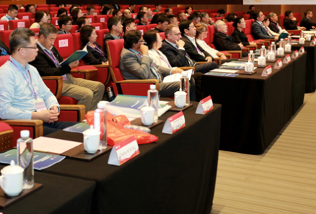  5th ISEG Intermediate Symposium in China, November, 2024 | 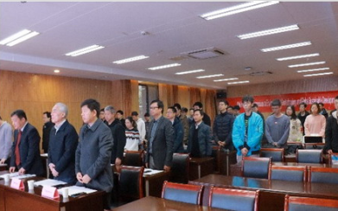  13th ISEG Symposium in China, December, 2022 | 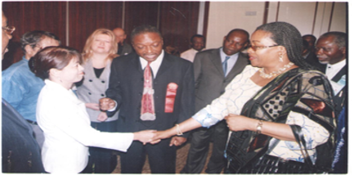  ISEG Conference in Abuja, Nigeria 2006 | 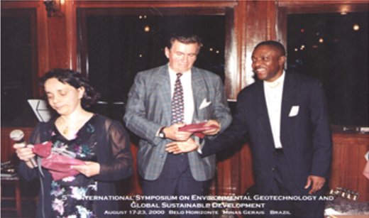  ISEG Conference in Hirozonte, Brazil, August, 2000

SCENES FROM KENYAN PARKS AND MUSEUMS
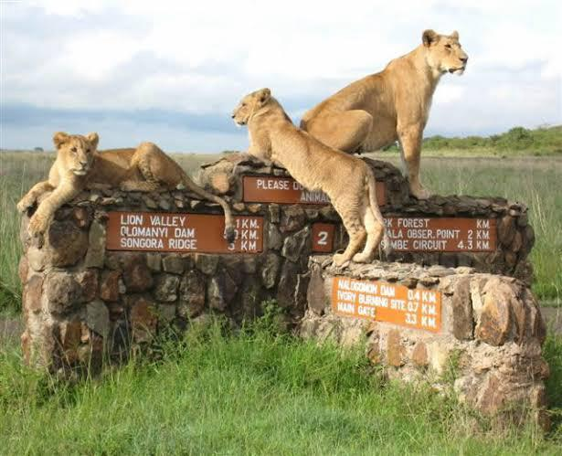  Nairobi National Park |   David Sheldrick Elephant Orphanage, Nairobi, Kenya | 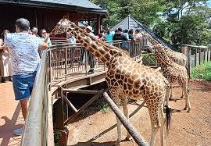  Giraffe Centre in Lang’ata, Kenya |   Bomas of Kenya – Dance through Culture

Pg. 5

